Match the photos of festivals/celebrations to the correct country.

1. 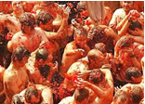 LA TOMATINA, BUÑOL
2. Turkey
3. Poland
4. Spain
5. Romania

Answer: c

1. 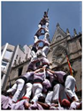 El ELS CASTELLERS, CATALUÑA/The Human Towers of Catalonia
2. Bulgaria
3. Romania
4. Sweden
5. Spain

Answer: d

1. 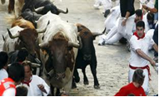The Festival of San Fermin, Pamplona
2. Italy
3. Spain
4. Romania
5. Turkey

Answer: b

1. 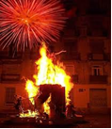 The Falles/ Las Fallas of Valencia
2. Spain
3. Romania
4. Poland
5. Turkey

Answer: a

1. 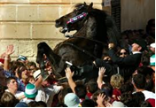 The Menorca fiesta of San Joan
2. Spain
3. Romania
4. Bulgaria
5. Italy

Answer: a